
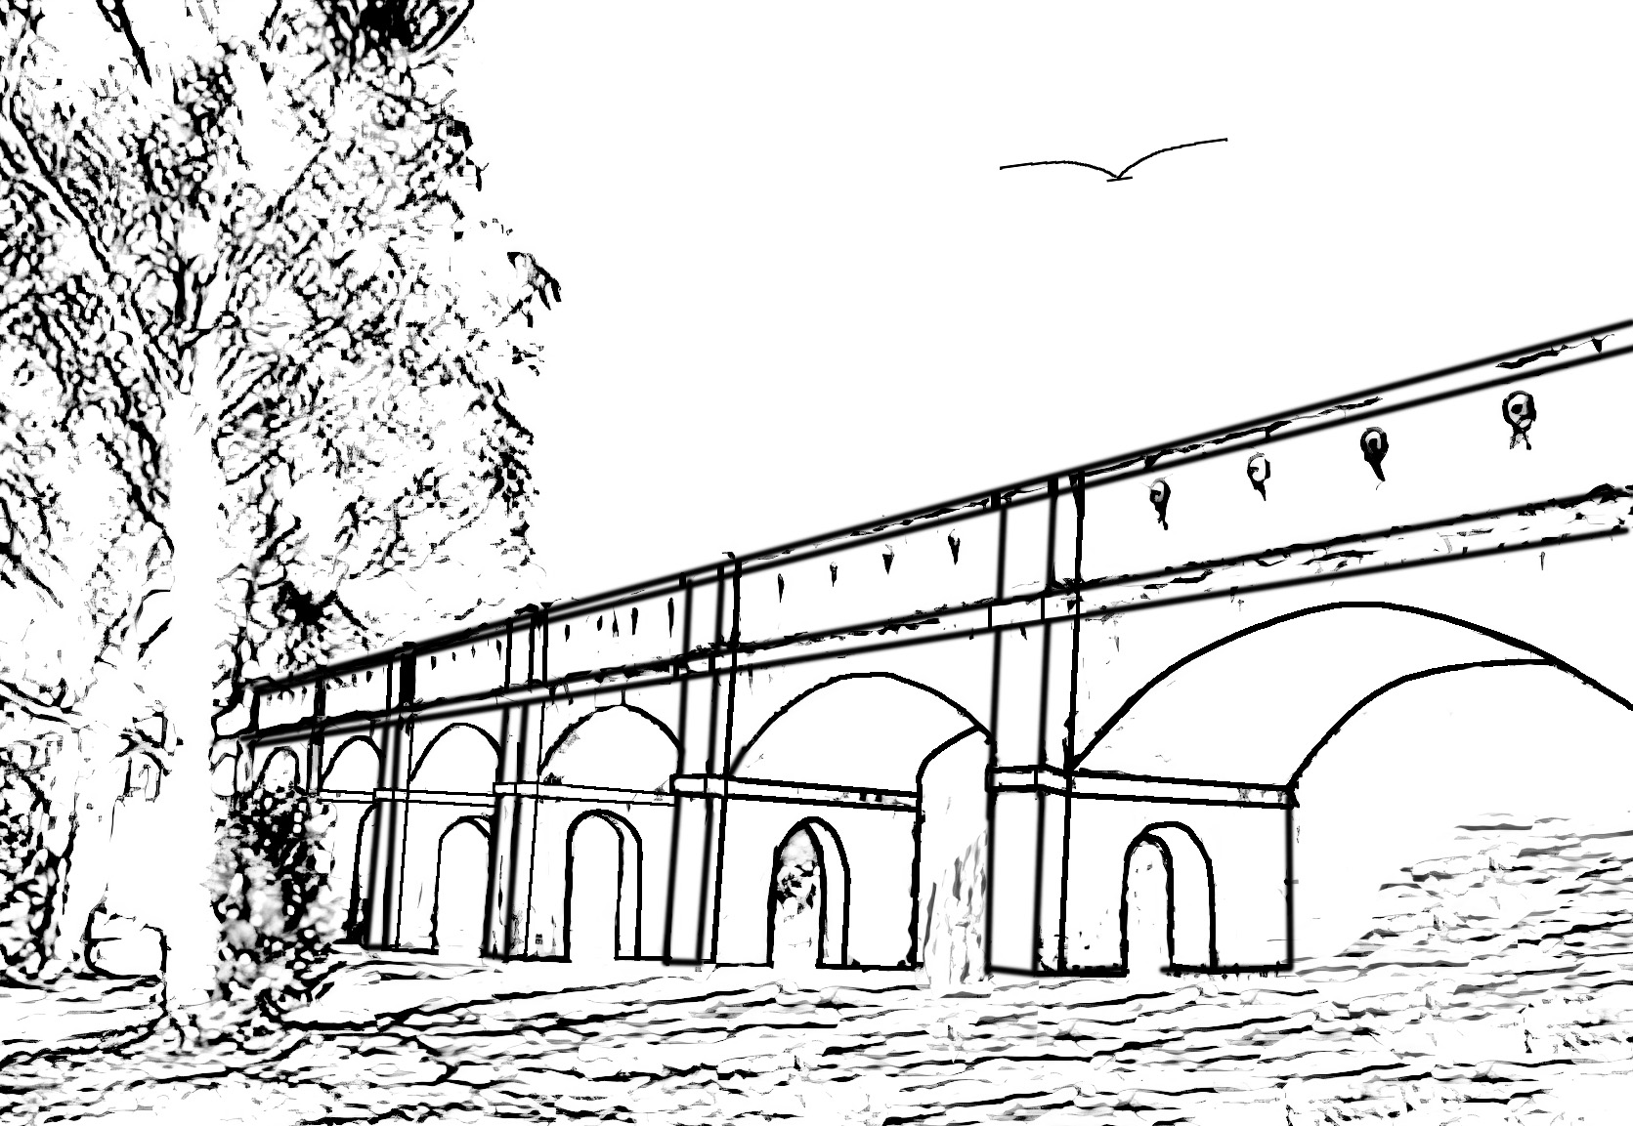
CATEGORY 4: KEEPER OF THE STONE
(CHILDRENS HERITAGE AWARD)
COLOURING COMPETITION
Kindergarten to Grade 4 (Inclusive)
Theme: Connection – To celebrate the rich and diverse stories of Cumberland
Sketch: Boothtown Aqueduct, Greystanes

BRIEF HISTORY OF BOOTHTOWN AQUEDUCT, GREYSTANES
Built in 19th century, Boothtown Aqueduct, is state significant as a key component of the Upper Nepean Scheme. This scheme was the outcome of the first major engineering investigation in NSW into the provision of an adequate and reliable water supply to meet the needs of a rapidly growing Sydney.
It is an excellent example of the techniques of 19th century hydraulic engineering, particularly the use of gravity directed water flow to supply a large area of Sydney with water.
Name: ……………………………………………………………
Grade/Year:………………………………………………………
School: …………………………………………………………...
Parent/Guardian Signature: ……………………………………..
Address:…………………………………………………………..
Contact Number: ………………………………………………...

Conditions of Entry
- All students from Kindergarten to Grade 4 (inclusive), attending a school within Cumberland City, are eligible to participate in the Colouring Competition.
- Ensure that the owner of the work has given permission for the work to be entered for this award.
- The decision of the Judging Panel will be final.
- If you have not heard back from Council by September 2024 regarding your entry, then you can consider that your entry was unsuccessful this time.
- All entries will be retained by Cumberland Council and may be used for promotional and other purposes at the discretion of Council.
- It is expected that entries will be competitive and there is no guarantee that you will receive an award if you make an entry.
- Details regarding individual scores given by Judges for each nomination and award will not be released to entrants or the public.
- By entering these awards, you agree to these conditions.

Where to send this entry form
Email: council@cumberland.nsw.gov.au
Subject Line: Local Heritage Awards Program Application, Category 4 – Attn: Urban Strategy and Planning

Please ensure all entrants’ details are completed before submitting to Council.

PRIVACY NOTE: Council will collect and hold the personal information contained in this application for the purpose of processing and considering your entry. The intended recipients of the personal information are officers within Council. The supply of personal information by you is voluntary, however if you cannot provide, or do not wish to provide the information sought, Council may be unable to process your entry.
You may make an application for access or amendments to your personal information held by Council under the Privacy and Personal Information Protection Act 1998 (PPIP Act) or the Government Information (Public Access) Act 2009 (GIPA Act). You may also make a request that Council suppress your personal information from a public register. Council will consider any such application in accordance with the PPIP Act.
Information provided to Council in correspondence, submissions or requests, including your personal information, may be made publicly available, including on Council’s website, under the GIPA Act. Please notify us if you object to the disclosure of your personal information.
ENTRIES CLOSE ON FRIDAY, 12 APRIL 2024.

